Generic Blank Game Design Document (GDD)

Your Game Logo



***‘Catchy Game Tagline’*** – ***Have you ever been desperate?***

This page: Table of Contents and Team Member Listing

|  |  |  |
| --- | --- | --- |
| Table of Contents  [1 Game Overview](https://n-xovwktmtjsnaxyc2mwes2xu7pohqedmdm6zjw5q-2lu-script.googleusercontent.com/userCodeAppPanel)  [2 High Concept](https://n-xovwktmtjsnaxyc2mwes2xu7pohqedmdm6zjw5q-2lu-script.googleusercontent.com/userCodeAppPanel)  [3 Unique Selling Points](https://n-xovwktmtjsnaxyc2mwes2xu7pohqedmdm6zjw5q-2lu-script.googleusercontent.com/userCodeAppPanel)  [4 Platform Minimum Requirements](https://n-xovwktmtjsnaxyc2mwes2xu7pohqedmdm6zjw5q-2lu-script.googleusercontent.com/userCodeAppPanel)  [5 Competitors / Similar Titles](https://n-xovwktmtjsnaxyc2mwes2xu7pohqedmdm6zjw5q-2lu-script.googleusercontent.com/userCodeAppPanel)  [6 Synopsis](https://n-xovwktmtjsnaxyc2mwes2xu7pohqedmdm6zjw5q-2lu-script.googleusercontent.com/userCodeAppPanel)  [7 Game Objectives](https://n-xovwktmtjsnaxyc2mwes2xu7pohqedmdm6zjw5q-2lu-script.googleusercontent.com/userCodeAppPanel)  [8 Game Rules](https://n-xovwktmtjsnaxyc2mwes2xu7pohqedmdm6zjw5q-2lu-script.googleusercontent.com/userCodeAppPanel)  [9 Game Structure](https://n-xovwktmtjsnaxyc2mwes2xu7pohqedmdm6zjw5q-2lu-script.googleusercontent.com/userCodeAppPanel)  [10 Game Play](https://n-xovwktmtjsnaxyc2mwes2xu7pohqedmdm6zjw5q-2lu-script.googleusercontent.com/userCodeAppPanel)  [10.1 Game Controls](https://n-xovwktmtjsnaxyc2mwes2xu7pohqedmdm6zjw5q-2lu-script.googleusercontent.com/userCodeAppPanel)  [10.2 Game Camera](https://n-xovwktmtjsnaxyc2mwes2xu7pohqedmdm6zjw5q-2lu-script.googleusercontent.com/userCodeAppPanel)  [10.2.1 HUD](https://n-xovwktmtjsnaxyc2mwes2xu7pohqedmdm6zjw5q-2lu-script.googleusercontent.com/userCodeAppPanel)  [10.2.2 Maps](https://n-xovwktmtjsnaxyc2mwes2xu7pohqedmdm6zjw5q-2lu-script.googleusercontent.com/userCodeAppPanel)  [11 Players](https://n-xovwktmtjsnaxyc2mwes2xu7pohqedmdm6zjw5q-2lu-script.googleusercontent.com/userCodeAppPanel)  [11.1 Characters](https://n-xovwktmtjsnaxyc2mwes2xu7pohqedmdm6zjw5q-2lu-script.googleusercontent.com/userCodeAppPanel)  [11.2 Metrics](https://n-xovwktmtjsnaxyc2mwes2xu7pohqedmdm6zjw5q-2lu-script.googleusercontent.com/userCodeAppPanel)  [11.3 States](https://n-xovwktmtjsnaxyc2mwes2xu7pohqedmdm6zjw5q-2lu-script.googleusercontent.com/userCodeAppPanel)  [11.4 Weapons](https://n-xovwktmtjsnaxyc2mwes2xu7pohqedmdm6zjw5q-2lu-script.googleusercontent.com/userCodeAppPanel)  [12 Player Line-up](https://n-xovwktmtjsnaxyc2mwes2xu7pohqedmdm6zjw5q-2lu-script.googleusercontent.com/userCodeAppPanel)  [13 NPC](https://n-xovwktmtjsnaxyc2mwes2xu7pohqedmdm6zjw5q-2lu-script.googleusercontent.com/userCodeAppPanel)  [13.1 Enemies](https://n-xovwktmtjsnaxyc2mwes2xu7pohqedmdm6zjw5q-2lu-script.googleusercontent.com/userCodeAppPanel)  [13.1.1 Enemy States](https://n-xovwktmtjsnaxyc2mwes2xu7pohqedmdm6zjw5q-2lu-script.googleusercontent.com/userCodeAppPanel)  [13.1.2 Enemy Spawn Points](https://n-xovwktmtjsnaxyc2mwes2xu7pohqedmdm6zjw5q-2lu-script.googleusercontent.com/userCodeAppPanel)  [13.2 Allies / Companions](https://n-xovwktmtjsnaxyc2mwes2xu7pohqedmdm6zjw5q-2lu-script.googleusercontent.com/userCodeAppPanel)  [13.2.1 Ally States](https://n-xovwktmtjsnaxyc2mwes2xu7pohqedmdm6zjw5q-2lu-script.googleusercontent.com/userCodeAppPanel)  [13.2.2 Ally Spawn Points](https://n-xovwktmtjsnaxyc2mwes2xu7pohqedmdm6zjw5q-2lu-script.googleusercontent.com/userCodeAppPanel)  [14 Art](https://n-xovwktmtjsnaxyc2mwes2xu7pohqedmdm6zjw5q-2lu-script.googleusercontent.com/userCodeAppPanel)  [14.1 Setting](https://n-xovwktmtjsnaxyc2mwes2xu7pohqedmdm6zjw5q-2lu-script.googleusercontent.com/userCodeAppPanel)  [14.2 Level Design](https://n-xovwktmtjsnaxyc2mwes2xu7pohqedmdm6zjw5q-2lu-script.googleusercontent.com/userCodeAppPanel)  [14.3 Audio](https://n-xovwktmtjsnaxyc2mwes2xu7pohqedmdm6zjw5q-2lu-script.googleusercontent.com/userCodeAppPanel)  [15 Procedurally Generated Content](https://n-xovwktmtjsnaxyc2mwes2xu7pohqedmdm6zjw5q-2lu-script.googleusercontent.com/userCodeAppPanel)  [15.1 Environment](https://n-xovwktmtjsnaxyc2mwes2xu7pohqedmdm6zjw5q-2lu-script.googleusercontent.com/userCodeAppPanel)  [15.2 Levels](https://n-xovwktmtjsnaxyc2mwes2xu7pohqedmdm6zjw5q-2lu-script.googleusercontent.com/userCodeAppPanel)  [15.3 Artificial Intelligence NPC](https://n-xovwktmtjsnaxyc2mwes2xu7pohqedmdm6zjw5q-2lu-script.googleusercontent.com/userCodeAppPanel)  [15.4 Visual Arts](https://n-xovwktmtjsnaxyc2mwes2xu7pohqedmdm6zjw5q-2lu-script.googleusercontent.com/userCodeAppPanel)  [15.5 Audio](https://n-xovwktmtjsnaxyc2mwes2xu7pohqedmdm6zjw5q-2lu-script.googleusercontent.com/userCodeAppPanel)  [15.6 Minimum Viable Product (MPV)](https://n-xovwktmtjsnaxyc2mwes2xu7pohqedmdm6zjw5q-2lu-script.googleusercontent.com/userCodeAppPanel)  [16 Wish List](https://n-xovwktmtjsnaxyc2mwes2xu7pohqedmdm6zjw5q-2lu-script.googleusercontent.com/userCodeAppPanel)   |  | | --- | |  | | Game Development Team Members    PRODUCER  Jiaxi Chen  Lule Yan    PRODUCTION MANAGER  Jiaxi Chen  Lule Yan    PRODUCTION COORDINATOR  Jiaxi Chen  Lule Yan  GAME DESIGNERS  Jiaxi Chen  Lule Yan  SYSTEMS/IT COORDINATOR  Jiaxi Chen  Lule Yan  PROGRAMMERS  Jiaxi Chen  Lule Yan  TECHNICAL ARTISTS  Jiaxi Chen  Lule Yan  AUDIO ENGINEERS  Jiaxi Chen  Lule Yan  UX TESTERS  Jiaxi Chen  Lule Yan |

|  |
| --- |
|  |

# 1 Game Overview

***Title: Happy Haunting***

***Platform: PC, MAC***

***Genre: FPS 3D Shooter***

***Rating: (10+) By Ourselves***

***Target: Casual gamer (aging from 12 - 30)***

***Who loves shooting game with horrible theme***

***Release date: Dec, 2019***

***Publisher: JiaxiChen & LuleYan***

***Description: Happy Haunting is a first-person shooting game. It is an endless survival game. The game happened in a hospital. The Zombie wants to let all the people be the same species. The Player is the one of the survivors. Hence, the Player must survive by avoiding zombie. The Zombie will spawn from three different places. The Player can get the score through killing the zombie in the game. There are many rooms and two of rooms have a potion which can help the player survive.***

# 2 High Concept

***Zombie comes to the hospital and attack the one of survival. Zombies are coming and looking for you. You can fight back with the gun. The player should appropriate use the potion to save your own life.***

# 3 Unique Selling Points

***Product by beginner. ( Easy to let unity beginner follow)***

***Beautiful Environment***

***Free***

***Achieve people's heroic dreams***

***Chinese element***

# 4 Platform Minimum Requirements

***Mac***

***PC***

***Windows XP or Windows 7 or later***

***Graphics card DX9 capabilities***

***Generally work great in the current PC***

# 5 Competitors / Similar Titles

***Realms of the Haunting by Steam***

# 6 Synopsis

***In a horrible hospital, all zombies chase you to the hospital and attack you. You found a gun to defeat zombie and want to fight back in a closed hospital.***

# 7 Game Objectives

***The objective of the game is to get the highest score and survive for as long as you can.***

# 8 Game Rules

***The game is that the zombie come from 3 different place and look for the player. The player gets points by killing zombie. The player can get 100 points from each enemy. The potion can save the player’s life and let the player speed up. The player can get the potion from two of those room and quest.***

# 9 Game Structure

***Level 1***

**↓**

***Start Page***

**↓**

***Gameplay***

**↓**

***Game Over (Score)***

# 10 Game Play

## 10.1 Game Controls

|  |  |
| --- | --- |
| ***W*** | ***Move forward*** |
| ***S*** | ***Move back*** |
| ***A*** | ***Move left*** |
| ***D*** | ***Move right*** |
| ***B*** | ***Badge system*** |
| ***Tab*** | ***Quest system*** |
| ***Mouse (Left)*** | ***Fire*** |
| ***Mouse moves left or right*** | ***Rotate*** |

## 10.2 Game Camera

***When the game starts, the camera will focus on muzzle. The player can use the mouse to rotate the direction, but it still follows where you rotate and focus on the muzzle. The rotation of the camera is 360 degree.***

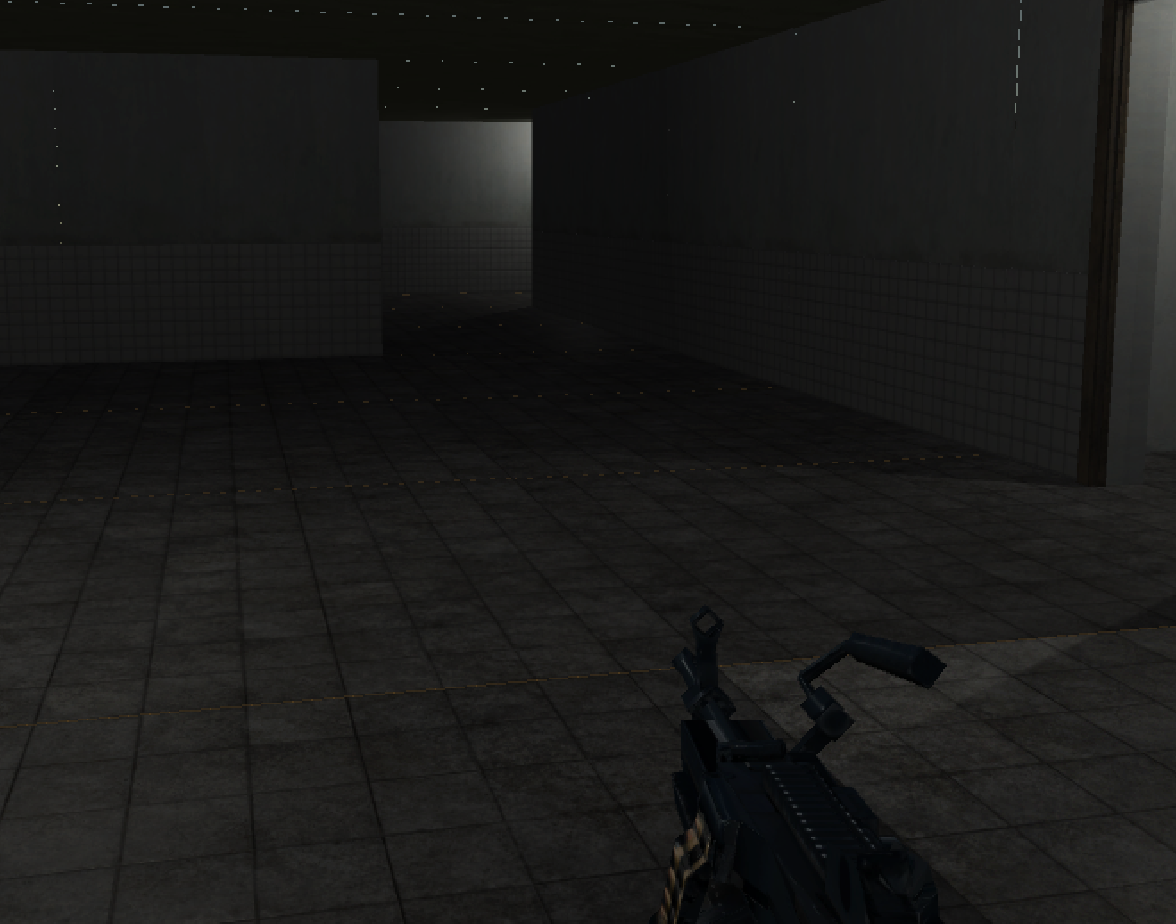

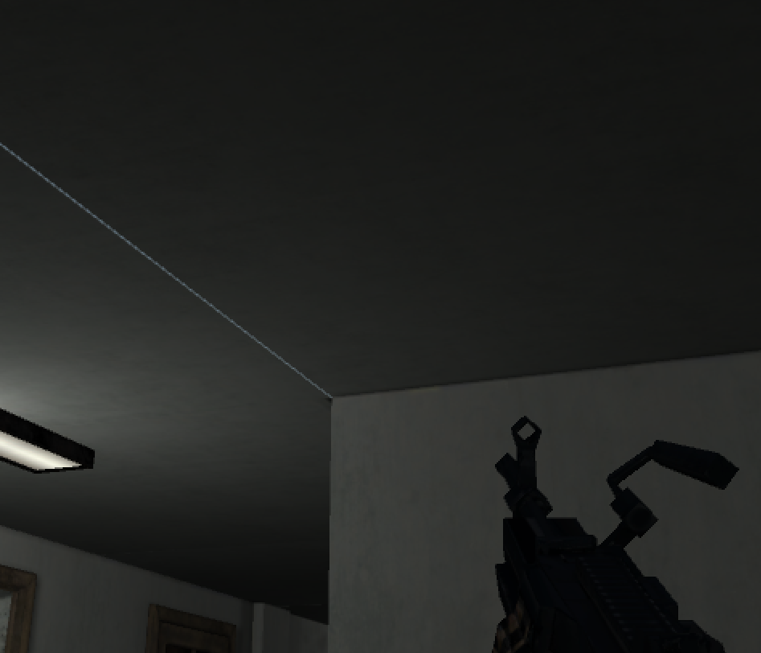

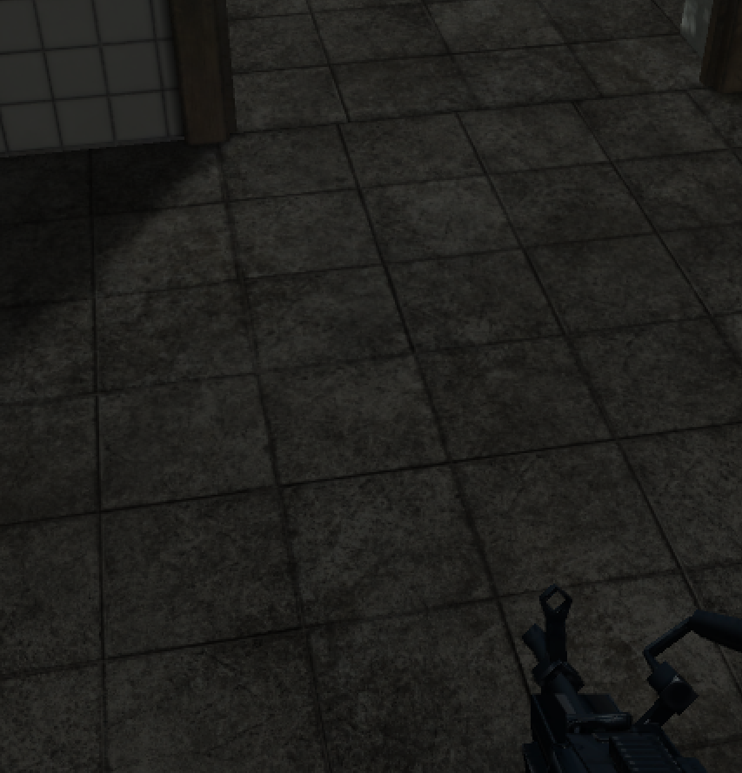

### 10.2.1 HUD

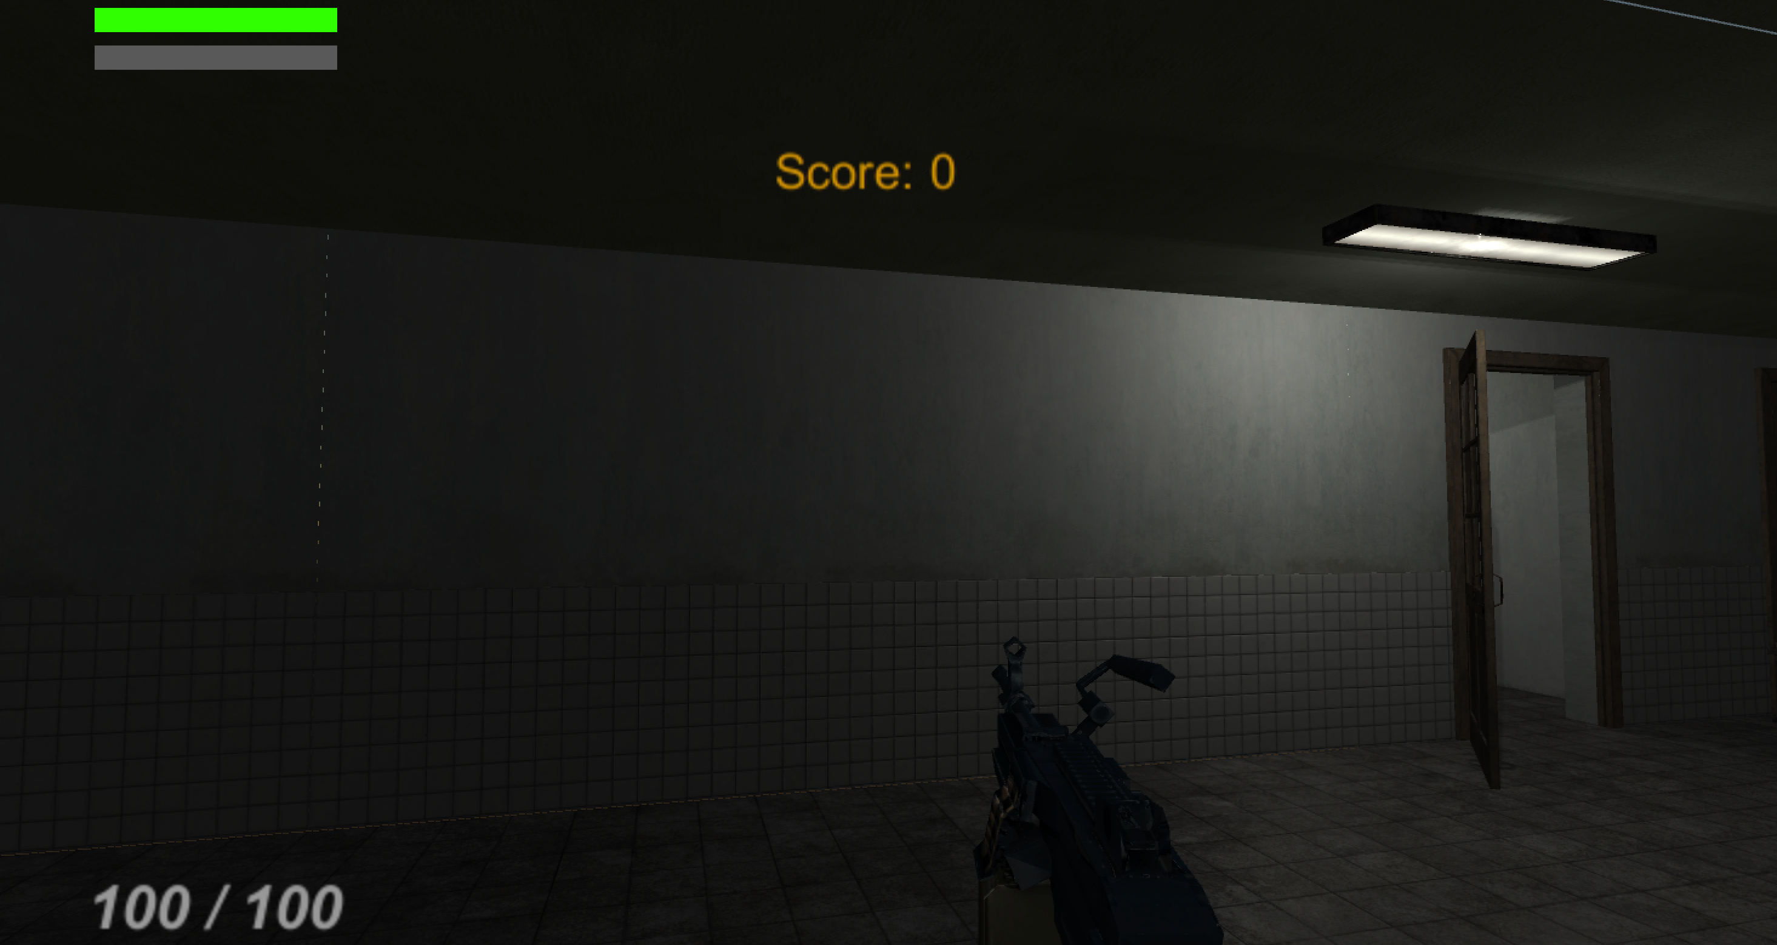

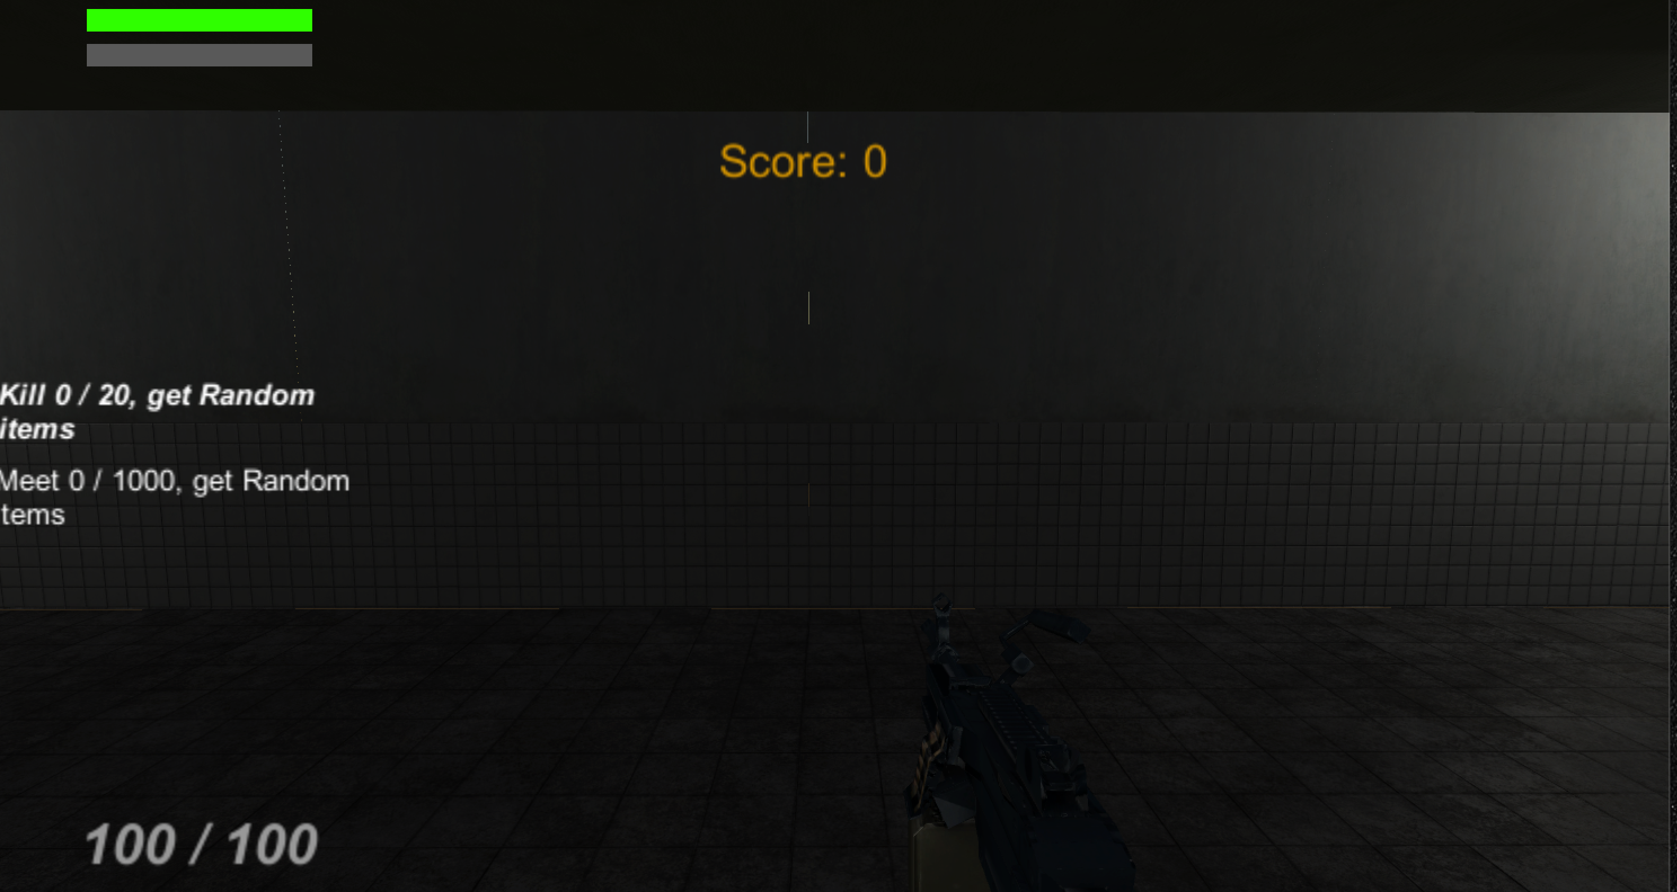

***Score:***

***Record How many points the player gets by killing zombie.***

***Ammo:***

***Display How many ammo lefts***

***Hp:***

***Display Player’s HP***

***Blue bar:***

***Display the time of speed up***

***Mission:***

***Display what the play can do to get the reward***

### 10.2.2 Maps

There are five rooms and many path to let the player walk through.

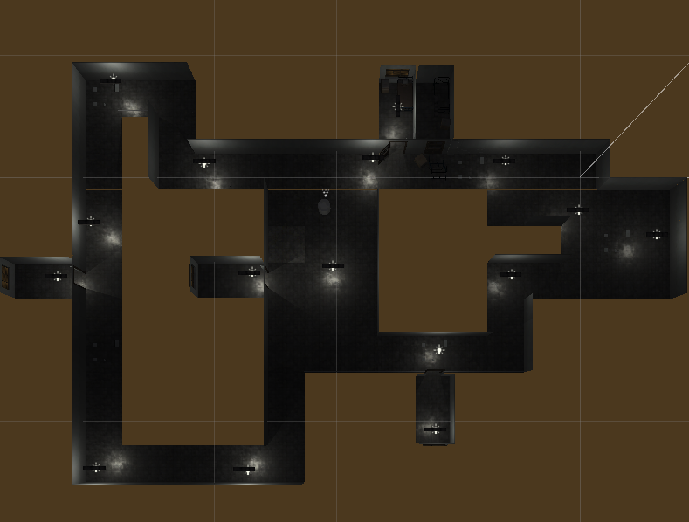

# 11 Players

## 11.1 Characters

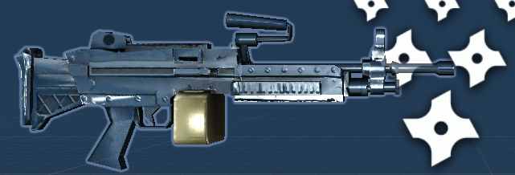

***In this game, we have special characters which is a gun and a hidden character. The hidden character uses the gun to kill the zombie.***

## 11.2 Metrics

***Speed: 3 – 6***

***Max Health: 100***

***Attack damage: 10***

***Time to attack: 0***

***Ammo: 100 (reload after running out of)***

## 11.3 States

***Shooting:***

***The animation will be displayed when the player use fire button to attack the zombie.***

***Reload:***

***The reload animation will be displayed after the ammo run out of and cause the ammo to be reset to 100***

## 11.4 Weapons



|  |  |  |  |  |
| --- | --- | --- | --- | --- |
| ***Weapon*** | ***Description*** | ***EFFECT*** | ***COLLDOWN*** | ***RETICLE*** |
| ***MachineGun*** | ***Make the damage on zombie*** | ***Deal 10 damage*** | ***0*** | ***NO*** |

# 12 Player Line-up

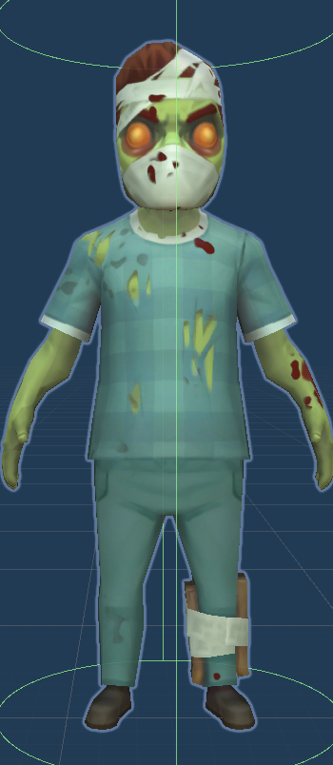

# 13 NPC

## 13.1 Enemies

***The zombie spawn from 3 different points located in the closed environment. They will look for the player. When they get close to the player, they will attack the player. When their hp become 0, they will fall to the floor. The zombie’s attacking damage will be increase after the player get every 1000 points.***

***Zombie***

|  |  |  |  |  |
| --- | --- | --- | --- | --- |
| ***Speed*** | ***Max HP*** | ***Score*** | ***Attack*** | ***Time to attack*** |
| ***0.5*** | ***100*** | ***100*** | ***10-∞*** | ***Each two Frames*** |

### 13.1.1 Enemy States

***Idle:***

***The Idle state is display when the zombie spawn and after the attack***

***Walk:***

***After the zombie spawn, the zombie will look for the player and the walk animation will be displayed***

***Attack:***

***The attack animation will be displayed after the zombie get close enough to the player***

***Death:***

***The death animation will be displayed after the zombie sustains too much damage***

### 13.1.2 Enemy Spawn Points

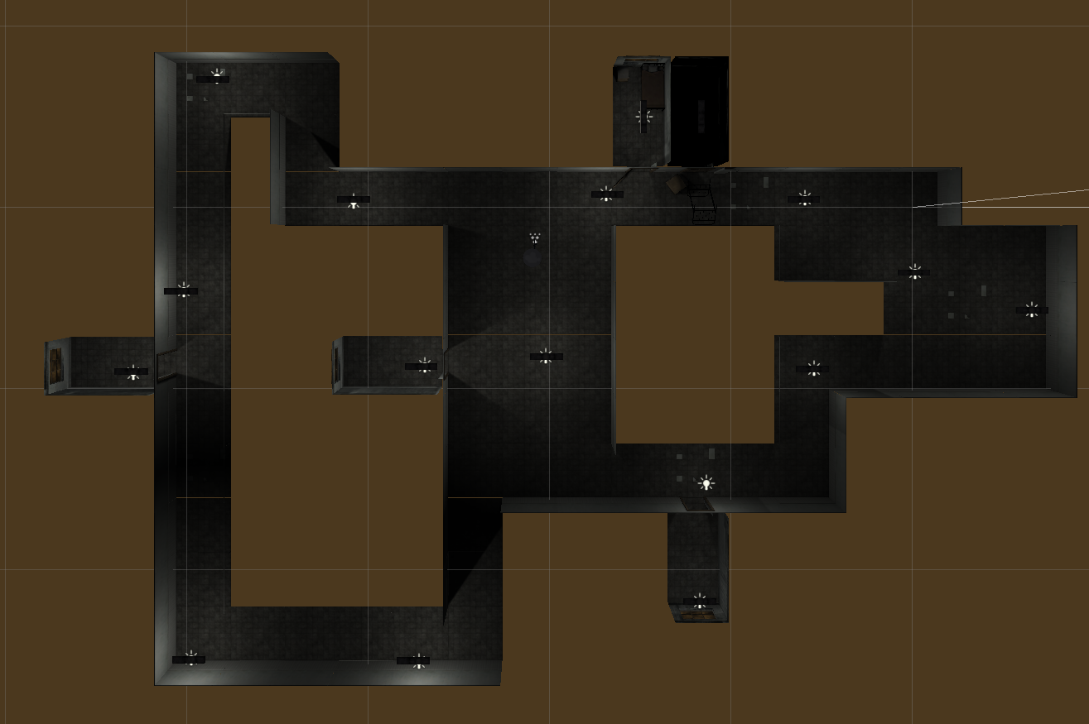



***Each zombie will be spawned in the spawn point in every 8-10 sec.***

|  |  |  |  |
| --- | --- | --- | --- |
| ***Enemy*** | ***SpawnPoint*** | ***SpawnRate*** | ***Max Enemies*** |
| ***Zombie*** | ***RedPoint (Above)*** | ***8 – 10sec*** | ***3 each spawn point*** |

## 13.2 Allies / Companions

***No Allies (Might be added in the future).***

### 13.2.1 Ally States

***No Allies (Might be added in the future).***

### 13.2.2 Ally Spawn Points

***No Allies (Might be added in the future).***

# 14 Art

## 14.1 Setting

***The game take place in the hospital where the player begins. The zombie will appear every 8 sec and they will look for the player. Many messy papers are on the ground. Some deserted beds are placed around the floor.***

## 14.2 Level Design





***The red point is the Zombie spawn point. The zombie will be spawned in every 8 – 10 sec and the max zombies for each spawn point is 3.***

***The purple point is the speed-up-potion spawn point. The max potion for each point is 1.***

***The blue point is the HP-potion spawn point. The max potion for each point is 1.***

## 14.3 Audio

|  |  |  |
| --- | --- | --- |
| NAME | CATEGORY | DESCRIPTION |
| Dungeon Character | Background music | Play during the game |
| fire | FX | Gun shooting |
| reload | FX | Gun reload |
| Coin_01 | FX | Get item |
| Zombie_Attack_Bite_001 | FX | Zombie attacked |
| Footsteps_Zombie_concret_003 | FX | Zombie walked |
| Foley_BodyFall_001 | FX | Zombie Died |
| Blood_Splash_A_001 | FX | Zombie On damage |

# 15 Procedurally Generated Content

## 15.1 Environment

***No PGC for environment. The whole environment was placed before the game starts by the creator.***

## 15.2 Levels

***No PGC for levels. There is only one levels and completed by the creator.***

## 15.3 Artificial Intelligence NPC

***The zombie uses the AI navigation to calculate the location of player and looks for the player.***

## 15.4 Visual Arts

***No PGC for visual arts. All visual arts are created before game starts.***

## 15.5 Audio

***No PGC for audio. The Audio was placed by the creator in the programming step.***

## 15.6 Minimum Viable Product (MPV)

***MachineGun (Character)***

***Built for the PC***

***Zombie (Enemy)***

# 16 Wish List

***Add more Zombie:***

***In the future, add more different enemy and boss.***

***Add more weapon:***

***Add more different gun or knife for changing by player***

***Add more Level:***

***Add more different difficulty level and boss level.***

***Optimize the Quest:***

***Add the random quest and more quest for reward.***